Lab Report –SERIES AND PARALLEL CIRCUITS
Name, course and lab section: _________________________________________

Part I – Series Circuits
In Figure 1 below, we have two resistors wired in series with one another. The red and black clips in the figure are connected to a voltmeter, and the icon labeled “I” is an ammeter, which is wired in series with the resistors. The box labelled “V” is the power supply, which is supplying the total voltage to the circuit.
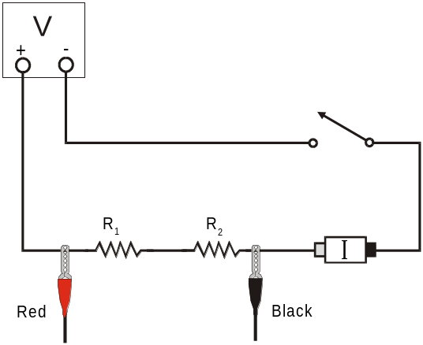
Figure 1

You have gone into the lab to find that someone has done current and voltage measurements for these resistor combinations already. The voltage across just resistor R₁ is found in the column for V₁; the voltage across just resistor R₂ is found in the column for V₂. The current through the circuit is found in the column for I.
Part I: Series circuits |  |  |  |  |  |  |  | R_{eq}  (Using the rule for series resistors)  (Ω)
 | R₁  (Ω) | R₂  (Ω) | I  (A) | V₁  (V) | V₂  (V) | V_{TOT}  (V) | R_{eq}  (Ohm Law)  (Ω) | R_{eq}  (Using the rule for series resistors)  (Ω)
1 | 10 | 10 | 0.251 | 2.519 | 2.498 | 5.00 | 19.92 | 20
2 | 10 | 33 | 0.117 | 1.187 | 3.826 | 5.00 | 42.74 | 43
3 | 33 | 33 | 0.076 | 2.511 | 2.502 | 5.00 | 65.79 | 66

- In the column that says R_{eq} (Ohm’s Law), use Ohm’s Law to calculate the equivalent resistance for the circuit. Show your calculations, and place your answers in the table.
Ans: According to Ohm’s law, V_{TOT} = I R_{eq} or, R_{eq} = (V_{TOT})/I

- R_{eq} = (5.00/0.251) Ω = 19.92 Ω
- R_{eq} = (5.00/0.117) Ω = 42.74 Ω
- R_{eq} = (5.00/0.076) Ω = 65.79 Ω
- In the column that says R_{eq} (using the rule for series resistors), use that rule to fill in values for the column. Show your calculations, and place your answers in the table.

Ans: The equivalent resistance Req of two series resistance R1 and R2 is given by,
Req =R1+ R2

- R_{eq} = (10+10) Ω = 20 Ω
- R_{eq} = (10+33) Ω = 43 Ω
- R_{eq} = (33+33) Ω = 66 Ω

PART I– ANALYSIS
3. Examine the results of Part I. What is the relationship between the three voltage readings: V1, V2, and VTOT?

Ans:
- V₁ = 2.519 V , V₂ = 2.498 V, V_{TOT} = 5.00 V then, (V₂/ V₁) = (2.498/2.519) = 0.992 so, V₂ = 0.992 V₁
and, ( V_{TOT}/ V₁) = (5.00/2.519) = 1.985 so, V_{TOT} = 1.985 V₁
and, (V_{TOT}/ V₂) = (5.00/2.498) = 2.002 so, V_{TOT} = 1.008V₂

- V₁ = 1.187 V , V₂ = 3.826 V, V_{TOT} = 5.00 V then, (V₂/ V₁) = (3.826/1.187) = 3.223 so, V₂ = 3.223 V₁
and, ( V_{TOT}/ V₁) = (5.00/1.187) = 4.212 so, V_{TOT} = 4.212 V₁
and, (V_{TOT}/ V₂) = (5.00/3.826) = 1.307 so, V_{TOT} = 1.307 V₂

- V₁ = 2.511 V , V₂ = 2.502 V, V_{TOT} = 5.00 V
then, (V₂/ V₁) = (2.502/2.511) = 0.996 so, V₂ = 0.996 V₁
and, ( V_{TOT}/ V₁) = (5.00/2.511) = 1.991 so, V_{TOT} = 1.991 V₁
and, (V_{TOT}/ V₂) = (5.00/2.502) = 1.998 so, V_{TOT} = 1.998 V₂

- For each of the three series circuits, compare the experimental results with the resistance calculated using your rule. Calculate the percent difference for each row, and report each here, showing your calculations.
Percent difference is used for comparing two experimental valuesx₁ and x₂:
% difference $= \frac{\left|x_{1}-x_{2}\right|}{x_{1}+x_{2}}×200\%$
Note that the “200%” comes from the fact that in the denominator of the formula, we are really comparing with the average of x₁ and x₂.

Ans:
- V_{eq}(from Ohm Law) = 19.92 Ω . Let us denote it as V_{eq}¹
So, V_{eq}¹ = 19.92 Ω
And the resistance calculated by series rule, V_{eq} = 20 Ω . Let us denote it as V_{eq}²
V_{eq}² = 20 Ω

Percentage difference = $\frac{|Veq1-Veq2| }{Veq1+ Veq2}$ $×200\%$ = $\frac{|19.92-20| }{19.92+20}$ $×200\%$
= 0.002$×200\%$
=0.40 %
- V_{eq}(from Ohm Law) = 42.74Ω . Let us denote it as V_{eq}¹
So, V_{eq}¹ = 42.74 Ω
And the resistance calculated by series rule, V_{eq} = 43 Ω . Let us denote it as V_{eq}²
V_{eq}² = 43 Ω

Percentage difference = $\frac{|Veq1-Veq2| }{Veq1+ Veq2}$ $×200\%$ = $\frac{|42.74-43| }{42.74+43}$ $×200\%$
= 0.00303$×200\%$
=0.61 %
- V_{eq}(from Ohm Law) = 65.79 Ω . Let us denote it as V_{eq}¹
So, V_{eq}¹ = 65.79 Ω
And the resistance calculated by series rule, V_{eq} = 66 Ω . Let us denote it as V_{eq}²
V_{eq}² = 66 Ω

Percentage difference = $\frac{|Veq1-Veq2| }{Veq1+ Veq2}$ $×200\%$ = $\frac{|65.79-66| }{65.79+66}$ $×200\%$
= 0.0016$×200\%$
=0.32 %
Part II – Parallel circuits
In the circuit below, you can see that someone has created Figure 2, showing the connections for a parallel circuit. As in the previous circuit, the red and black clamps are used to show where we measure the voltage applied to both resistors. The “I” indicates where we have inserted the ammeter to measure the total current.
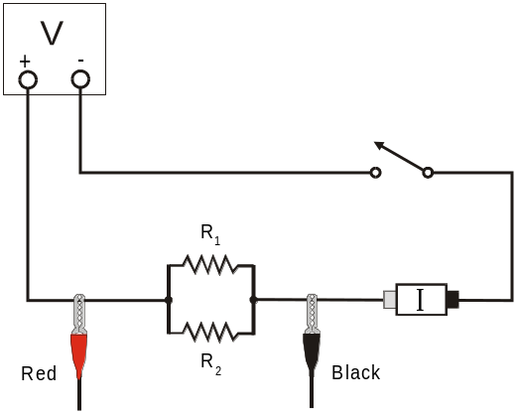
Figure 2

In the table below, you can see that again, someone has taken current and voltage readings for the circuit, using different values for the two resistors.

Part II: Parallel circuits |  |  |  |  |  |  |  | R_{eq}  (Using the rule for parallel resistors)  (Ω)
 | R₁  (Ω) | R₂  (Ω) | I  (A) | V₁  (V) | V₂  (V) | V_{TOT}  (V) | R_{eq}  (Ohm Law)  (Ω) | R_{eq}  (Using the rule for parallel resistors)  (Ω)
1 | 33 | 33 | 0.309 | 5.00 | 5.00 | 5.00 | 16.18 | 16.5
2 | 33 | 47 | 0.262 | 5.00 | 5.00 | 5.00 | 19.08 | 19.39
3 | 47 | 47 | 0.215 | 5.00 | 5.00 | 5.00 | 23.26 | 23.5

- In the column that says R_{eq} (Ohm’s Law), use Ohm’s Law to calculate the equivalent resistance for the circuit. Show your calculations, and place your answers in the table.
Ans : According to Ohm’s law, V_{TOT} = I R_{eq} or, R_{eq} = (V_{TOT})/I

- R_{eq} = (5.00/0.309) Ω = 18.18 Ω
- R_{eq} = (5.00/0.262) Ω = 19.08 Ω
- R_{eq} = (5.00/0.215) Ω = 23.26 Ω

- In the column that says R_{eq} (using the rule for parallel resistors), use that rule to fill in values for the column. Show your calculations, and place your answers in the table.

Ans: The equivalent resistance R_{eq} of the two resistance R₁ and R₂ follows the relation,
$\frac{1}{R_{eq}}$ = $\frac{1}{R_{1}}$ + $\frac{1}{R_{2}}$ = $\frac{R_{1 }+R_{2}}{R_{1 }×R_{2}}$ or, R_{eq} = $\frac{R_{1 }×R_{2}}{R_{1 }+R_{2}}$

R_{eq} = $\frac{33×33}{33+33}$ Ω = 16.5 Ω

R_{eq} = $\frac{33×47}{33+47}$ Ω = 19.39 Ω
3.
R_{eq} = $\frac{47×47}{47+47}$ Ω = 23.5 Ω

PART II – ANALYSIS
- Examine the results of Part II. What is the relationship between the three voltage readings: V1, V2, and VTOT?

Ans:
From the table of part II we can see that for all the cases ( case 1, case 2, case 3) , V₁ = V₂ =V_{TOT} = 5.00 V

- For each of the three parallel circuits, find the percent difference between your two values of the equivalent resistance. Show your calculations.

Ans:
- V_{eq}(from Ohm Law) =16.18 Ω . Let us denote it as V_{eq}¹
So, V_{eq}¹ = 16.18 Ω
And the resistance calculated by series rule, V_{eq} = 16.5 Ω . Let us denote it as V_{eq}²
V_{eq}² = 16.5 Ω

Percentage difference = $\frac{|Veq1-Veq2| }{Veq1+ Veq2}$ $×200\%$ = $\frac{|16.18-16.50| }{16,18+16.50}$ $×200\%$
= 0.0098$×200\%$
=1.96 %
- V_{eq}(from Ohm Law) = 19.08Ω . Let us denote it as V_{eq}¹
So, V_{eq}¹ = 19.08 Ω
And the resistance calculated by series rule, V_{eq} = 19.39 Ω . Let us denote it as V_{eq}²
V_{eq}² = 19.39 Ω

Percentage difference = $\frac{|Veq1-Veq2| }{Veq1+ Veq2}$ $×200\%$ = $\frac{|19.08-19.39| }{19.08+19.39}$ $×200\%$
= 0.008$×200\%$
=1.6 %
- V_{eq}(from Ohm Law) = 23.26 Ω . Let us denote it as V_{eq}¹
So, V_{eq}¹ = 23.26 Ω
And the resistance calculated by series rule, V_{eq} = 23.5 Ω . Let us denote it as V_{eq}²
V_{eq}² = 23.5 Ω

Percentage difference = $\frac{|Veq1-Veq2| }{Veq1+ Veq2}$ $×200\%$ = $\frac{|23.26-23.5| }{23.26+23.5}$ $×200\%$
= 0.005$×200\%$
=1.0 %

Part III – Currents in a Series circuit
In Figure 3 below, we have two resistors in series, and there is an ammeter in between the resistors as well as an ammeter to the right of the 47 ohm resistor.
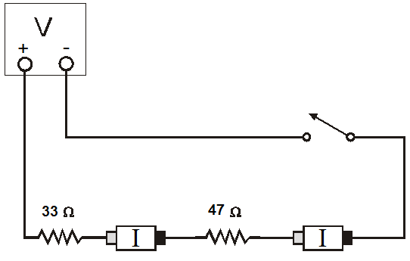
Figure 3

- Determine what the values of the current will be for each of the following empty cells in the table below. Show your calculations and/or explain how you determined what values for current go in each cell.

Part III: Currents in Series
 | R1 (Ω) | R2 (Ω) | I₁ (A) | I₂ (A) | I_{Source} (A)
Series | 33 | 47 | 0.0626 | 0.0626 | 0.0626

Ans:
Taking V = 5V

We can see that R₁ and R₂ are in series connection. So, the current through R₁ will be equal to current through R₂ and also equal the total current through the circuit, I_{source} .
Now, total resistance of the circuit, R = equivalent resistance of R₁ and R₂
= (33+47)Ω = 80Ω

Then, I_{source} = (V/R) = (5/80)A = 0.0626A
Then, I₁ = I₂ = I_{source} = 0.0626A = 62.6mA

Part IV – Currents in a Parallel Circuit
In Figure 4 below, we show circuit diagrams in which we have connected a parallel circuit using the 33 ohm resistor and the 47 ohm resistor. In the left panel we show the circuit with two ammeters, one wired in series with each of the two resistors, which will measure the current through each resistor individually. In the right panel, a single ammeter is placed after the parallel resistor combination, in order to measure the total current output from the voltage source.
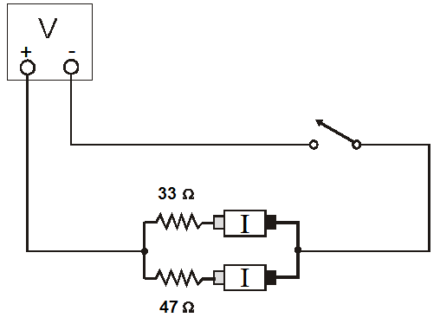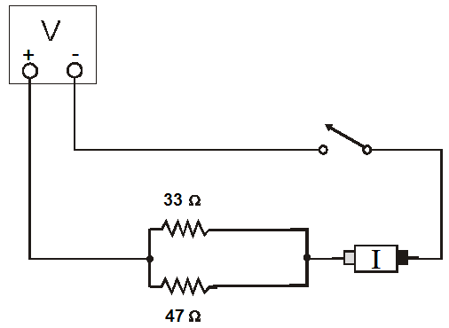
Figure 4

- Determine what the values of the current will be for each of the following empty cells in the table below. Show your calculations and/or explain how you determines what values for current go in each cell.
Part IV: Currents in Parallel
 | R1 (Ω) | R2 (Ω) | I₁ (A) | I₂ (A) | I_{Source} (A)
Parallel | 33 | 47 | 0.1515 | 0.1064 | 0.2579

Ans:
Taking V=5V
Since R₁ and R₂ are in parallel combination then the voltage across the resistances R₁ and R₂ will be the same and that volage will be equal th the supply voltage 5V
So, current through R₁, ( I₁) = (Voltage across R₁) /R₁
Or, I₁ = (5/33) A = 0.1515A
And I₂ = (5/47)A = 0.1064A
Equivalent resistance of the circuit where R₁ and R₂ are in parallel combination = (R₁R₂)/(R₁+R₂) = (33$×47)/(33+47)$Ω = 19.3875 Ω
Then,
I_{source} =(5/19.3875)A = 0.2579A

PARTsIII-IV –ANALYSIS
- What did you discover about the relationship between the currents flowing through two resistors connected in a series (Part III)? How do those currents compare with the current from the voltage source?

Ans:
Current through both the resistor R1 and R2 are equal and the current from the voltage source is also equal to the current through R₁ and R₂ .

- What did you discover about the relationship between the currents flowing through two resistors connected in parallel (Part IV)? How do those currents compare with the current from the voltage source?

Ans:
Current through R₁, (I₁) =0.1515A
Current through R₂, (I₂) =0.1064A
Current from the source, I_{source} = 0.2579 A
Then,
(I₁/I₂) = (0.1515/0.1064) = 1.424 so, I₁ = 1.424I₂
(I₁/I_{source}) = (0.1515/0.2579) = 0.578 so, I₁ = 0.587I₂
(I₂/I_{source}) = (0.1064/0.2579) = 0.412 so, I₁ = 0.412I₂

- If the two measured currents in your parallel circuit were not the same, which resistor had the larger current going through it? Why?
Ans: The resistor R₁ = 33Ω had the larger current because the value of R₁ is less than the value of R₂ . So, R₁ resists less than R₂ for current flow so larger amount of current passes through R₁ .

Part V – A Combination Circuit
The previous lab occupant left a diagram of one final circuit that involves both series and parallel connections – but they did not write down any measurements. Use the questions and table below to predict what the resulting values for this circuit would be.
Reminder: Be sure to show your calculations at every step!
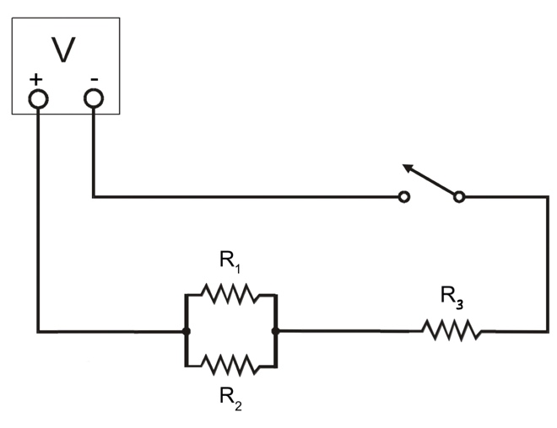
Figure 5

- Use the rules for series and parallel resistors (as appropriate) to find:
  - the equivalent resistance of resistors R₁ and R₂:
Ans: R₁₂ = $\frac{R_{1 }×R_{2}}{R_{1 }+R_{2}}$Ω
  - the equivalent resistance of the whole circuit:

Ans: R_{eq}= ( $\frac{R_{1 }×R_{2}}{R_{1 }+R_{2}}+ R_{3})$ Ω if R₁₂ is the equivalent resistance of R₁ and R₂ then $\frac{1}{ R_{12}}$ = $\frac{1}{R_{1}}$ + $\frac{1}{R_{2}}$ = $\frac{R_{1 }+R_{2}}{R_{1 }×R_{2}}$ Since R₁₂ and R₃ are in series combination Then, R_{eq} = R₁₂ + R₃ = ( $\frac{R_{1 }×R_{2}}{R_{1 }+R_{2}}+ R_{3})$ Ω
- Use Ohm’s Law to predict the total current being supplied by the power source. Assume that the power source is set to a voltage of 5.000 V. Then, use the rules for current in series or parallel circuits (as appropriate) to predict the current through resistor R₃, and enter that value in the table below.

Ans:
I_{source} = (5/R_{eq}) A

Since, R₃ is in series then the current through R₃, I₃ = I_{source} = (5/R_{eq}) A
- Use Ohm’s Law to predict the voltage across resistor R₃. Then, use the rules for voltage in series and parallel circuits (as appropriate) to predict the voltages across resistors R₁ and R₂. Write all of these predictions into the table below.
Ans: voltage drop across the resistance R₃ is given by V₃ =current through R₃ $×$ Resistance (R₃) =I_{source}$×$ R₃=(5/R_{eq})$×R$₃ Since R₁ and R₂ are parallel they will have the same vol voltage acreoss them. Then voltage drop across R₁ and R₂ is given by, V₁₂ = (5 – V₃) = (5- 5R₃/R_{eq}) = 5(1-R₃/R_{eq})
- Use Ohm’s Law to predict the currents passing through resistors R₁ and R₂, and enter the values in the table below.
Ans : Then, current through R₁ is , I₁ = V₁₂/R₁ = $\frac{5}{R_{1}}$(1-R₃/R_{eq}) and current through R₂ is , I₂ = V₁₂/R₂ = $\frac{5}{R_{2}}$(1-R₃/R_{eq})
Part V: A Combination Circuit
Resistors | Voltage across  that Resistor | Current through  that Resistor
R₁ = 10 Ω | 1V | 0.1A
R₂ = 47 Ω | 1V | 0.021A
R₃ = 33 Ω | 4V | 0.1212A

Calculation: R_{eq} = R₁R₂/(R₁+R₂) + R₃ = [10$×$47/(10+47) + 33]Ω =(8.25+33)Ω = 41.25Ω

Then, V₁₂ = 5(1-R₃/Req) = 5(1-33/41.25) V = 1V = votage across R₁ = voltage across R₂ (since they are in parallel combination)
Current through R₁ is , I₁ = V₁₂/R₁ =( 1/10)A = 0.1 A
Current through R₂ is, I₂ = V₁₂/R₂ =( 1/47)A = 0.021 A
Voltage across R₃ is V₃ = 5R₃/R_{eq} =(5$×33$/41.25) V = 4V
Cureent through R₃ is I₃ = V₃/R₃=(4/33)A=0.1212A

- Now that you’ve fully predicted the parameters of the circuit, the scribblings of your predecessor make more sense. You see now that they measured the voltage and current for resistor R₂ to be 1.008 V and 0.021 A, respectively. Calculate the percent difference between your predictions and these measurements.
Ans: My calculated voltage (V₂)_{my} = 1V and their calculated (V₂)_{their} = 1.008 V so , percent difference = (1.008-1)$×$ 100% = 0.8% My calculated current = 0.021 A their current = 0.021 A . so there is no difference.
- How would you repeat the measurements your predecessor made on resistor R₂? Explain in words below, and also draw/label the voltmeter and ammeter placements on Figure 5.
Ans: I will put the two clamps of the voltmeter at the two ends of the resistor R₂ and connect an ammeter in series with R₂. 